About Us
The Tshokey Dorji Foundation (TDF) was established in 2009 by His Holiness the Seventh Chabjye Namkhai Nyingpo Rinpoche, Tenzin Gyaltshen, with the support of his devoted followers. The Foundation is named after Guru Tshokey Dorji, one of the eighth manifestations of Guru Padmasambhava, as He best embodies the aspirations and objectives of the Foundation. Guru Rinpoche’s manifestation as “Tshokey Dorji - the Lotus-Born” ensures the continuity and flourishing of the Buddha Dharma, particularly the secret Vajrayana teachings, for the benefit of all sentient beings. This remains the core objective of the Foundation, as envisioned by its Founder and President, His Holiness Namkhai Nyingpo Rinpoche.
Recognizing that the preservation of Buddha Dharma relies on ordained practitioners, the Foundation is deeply committed to supporting and sustaining monastic institutions where Dharma is taught and upheld. His Holiness works tirelessly to safeguard and promote the Dharma, both in Bhutan and beyond. At present, Rinpoche bears the immense responsibility of supporting over 1,000 monks, fourteen monasteries, two meditation centers, and numerous religious and charitable initiatives.
Tshokey Dorji Foundation seeks to share this noble responsibility with His Holiness the Seventh Namkhai Nyingpo Rinpoche and his future reincarnations, ensuring that the sacred teachings and practices of the Buddha Dharma continue to thrive for generations to come.

Vision
Foster the Buddha’s Dharma for the benefit of all sentient beings.
Mission
- Inspire and motivate people to understand, appreciate and realize the values of Buddha Dharma.
- Impart wisdom, compassion, and inner peace.
- Maintain and sustain Bumthang Lhodrak Kharchhu Monastery and its affiliate Monasteries, Shedras, Drubdheys, and Gomdheys.
- Foster the continuity of Buddhist teachings and spiritual traditions.

- Core Values
  - Compassion: Serve communities with empathy, kindness, and a deep sense of responsibility toward social well-being.
  - Integrity: Uphold the highest ethical standards, ensuring transparency, accountability, and honesty in all our endeavors.
  - Sustainability: Promote long-term, environmentally and socially sustainable solutions that create lasting positive impact.
  - Empowerment: Strive to uplift individuals and communities by providing the necessary tools, knowledge, and support to improve their lives.
  - Excellence: Provide the highest standards of quality and impactful services through innovative practices.
Objectives of the Foundation
The main objectives of the Foundation are the following:
- Provide financial support and other non-financial assistance necessary for the continued sustenance of Bumthang Kharchhu Monastery and its allied centers.
- Provide a center to study, support, disseminate and practice the Buddha Dharma.
- and thereby serve to hold, the teachings of the Buddha;
- Coordinate and conduct Dharma Teachings (Choeshed Layrims) to the devotees and followers of Buddha Dharma and the general public;
- Provide support to the aggrieved individuals and organizations during times of disasters;
- Organize and conduct prayers for the peace and wellbeing of the king, country and the people;
- Support the members of the Foundation during times of illness and deaths to conduct prayers (Ngo Moenlam, Tsedup, etc.) by coordinating with Bumthang Kharchhu Monastery or its affiliates, as appropriate;
- Generate and provide funds for the continued sustenance of affiliate monasteries, Dharma centers, and institutions both within and beyond Bhutan
- Provide subsistence and other livelihood support to the revered members of the Sangha in general including monks, nuns, and Gomchens.

Governing Board
  - Patron: His Holiness Namkhai Nyingpo Rimpochhe.
  - Board of Trustees as the Governing Body of the Foundation.
  - Council of Khenlops.
  - Fund Raising and Investment Committee.
  - Regional/Dzongkhag Coordination Committee

Board of Trustees
Chairperson: Khenchen Karma Wangchuk
Council of Khenlops: Khenpo Thekchok Dorji
Council of Khenlops: Lam Tashi
Chairperson of Dzongkhag Coordination Committee: Mr. Karma Phuntsho
Chairperson of Fund Raising & Investment Committee: Mr. Dechen Wangdi
VC: Mr. Sither Dorji
Treasurer: Mr. Sonam Lhendrup
Executive Director, Member Secretary: Mr. Sonam Tenzin.

Dzongkhag Coordination Committee
Board of Trustees
Profile of Office Bearers
Mr. Sonam Tenzin – Executive Director

Profile of Sonam Tenzin
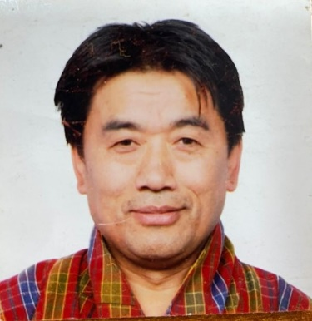
Mr. Sonam Tenzin serves as the Executive Director of the Tshokey Dorji Foundation (TDF), leading strategic collaborations, governance integration, and investment frameworks to drive sustainable growth and impactful outcomes.
With over 23 years in public service and more than three years in the private sector, Sonam brings extensive leadership experience. He has held senior executive roles in the Government of Bhutan, including Director of the Competition and Consumer Affairs Authority under the Ministry of Economic Affairs and Director of the Department of Information and Media under the Ministry of Information and Communications. His tenure in the Ministry of Finance saw his progression from Finance Officer and Senior Budget Officer to Chief Planning Officer and later Chief of the Department of Macroeconomic Affairs, where he played a key role in public policy, macroeconomic strategy, public finance, and regulatory oversight.
In the private sector, Sonam has demonstrated strong financial leadership and entrepreneurial acumen. He has served as Executive Director in two leading Bhutanese companies, contributing to business growth, financial stewardship, and entrepreneurship development.
Sonam holds an MBA in Finance from Edith Cowan University, Australia, a Postgraduate Diploma in Financial Management, and a Bachelor’s Degree in Economics (Honours) from Sherubtse College, Delhi University. His diverse expertise and leadership continue to enhance TDF’s mission of preserving and promoting Buddha Dharma while fostering governance excellence and sustainable impact.
Profile of Lopen Jigme Tenzin – Administrative Manager

Profile of Lopen Tshering Dorji – Program Manager

Profile of Ms. Kinley Dema – Finance Manager

Brochures:
Downloadable brochures that summarize TDF’s mission, history, and programs (PDF format).

Monastic Centers
- Overview: Description of all the affiliated monastic centers under TDF.
- Interactive Map: Pinpoint the locations of each monastic center in Bhutan and globally.
- Centers:
  - Detailed pages for each center with:
    - History.
    - Current activities/programs.
    - Resident monks and teachings offered.
    - Photo galleries.
Lhodrak Kharchu Gaden Dudjom Nampar Gyalwai Ling
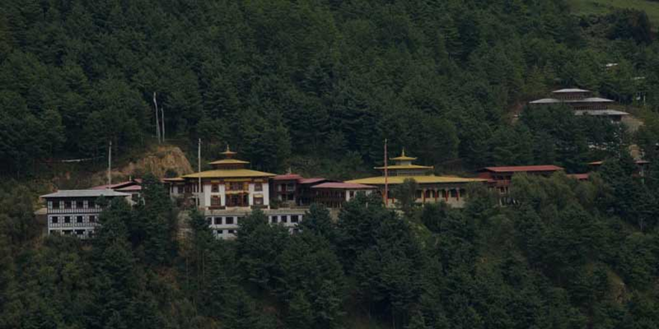
Lhodrak Kharchu Gaden Dudjom Nampar Gyalwai Ling, popularly known as Lhodrak Kharchu Drastang (Monastery), was founded by His Holiness the Seventh Namkhai Nyingpo Rinpoche, Jamyang Yeshey Tenpai Gyeltshen. Located at the sacred site blessed by Dakinis, perched on a mountain stretch with a commanding view of Chamkhar valley, the Monastery was established in 1982 by His Holiness the Seventh Namkhai Nyingpo Rinpoche.
The Lhodrak Kharchu Monastery holds a significant place in the lineage of Nub Namkhai Nyingpo, one of the 25 disciples of Guru Padmasambhava. The seventh Namkhai Nyingpo ascended the throne in 1972. At his very early age, His Holiness practice Buddha Dharma and established Lhodrak Kharchu Monastery in Bumthang. Initially, it started with a modest two-storied temple, a library and a few temporary dormitories for around 70 resident monks. The monks were provided with free accommodation, food, teachings and other basic facilities through donations and contributions from the local communities. Due to extraordinary devotion of people to His Holiness, the number of monks increased gradually and the teaching and practice of Buddha Dharma advanced and spread far beyond Bumthang.
Under the compassion leadership of His Holiness, the Lhodrak Kharchu Monastery follows an open-door policy and offered enrolment to everyone who wishes to join the Monastery. There was not a single case, who was not offered enrolment in the Monastery. Moreover, most of them come from disadvantaged families and far remote areas of Bhutan, the need for more amenities to accommodate the increasing number of monks and practitioners became imminent. During such a difficult period, His Majesty the 4th King Jigme Singye Wangchuck visited the monastery and commanded the government to support the expansion of the monastery.
Over the years, the Monastery has experienced remarkable growth, both in number of monks and facilities. Today, the Monastery comprises the following facilities:
- Tshokhang/Grand Assembly Hall.
- Residential quarters (for Trulkus, Khenpos, and Lamas & Lopens (teachers).
- Drasha/Hostel
- Drupkhangs/Meditation Centers).
- Academic building
- Library
- Administration and Management office
- Kitchen and dinning
- Guest house.
In addition, the Monastery has established fourteen branch monasteries across far remote districts of Bhutan including one in India, and four Dharma Centers (Choetshog), one each in Taiwan, Australia, the US, and Canada.
At present, the Monastery has 936 monks of which around 62% (585 monks) resides at Lhodark Kharchu and remaining 38% (351 monks) resides across fourteen branch monasteries. There are 21 trulkus, 25 khenpos, 227 lams/lopens and 40 hermits at its four meditation centers. The name of the Monastery, location, and number of monks in each of the branch monasteries including at the Lhodrak Kharchu are provided below:
Sl. No. | Name of the Monastery | Location | No. of monks
1 | Lhodrak Kharchu Gaden Dudjom Nampar Gyalwai Ling | Bumthang, Bhutan | 585
2 | Thrigoan Pema Yoeling | Tashiyangtsi, Bhutan | 57
3 | Jamkhar Duedheling | Tashiyangtsi, Bhutan | 39
4 | Ugyen Khedrup Jatsholing | Bardo, Zhamgang | 13
6 | Dhongak Lungten Chhoeling | Domkhar, Lhuntsi | 13
7 | Ugyen Shedrup Gatsheling | Saling, Mongar | 10
8 | Jampachokherling Ani Shedra | Mongar | 30
9 | Thekcholing | Tsakaling, Mongar | 27
10 | Ugyen Samtenling | Samtse, Bhutan | 44
11 | Yoeselcholing | Sarpang, Bhutan | 32
12 | Phendheyling | Tsenkhar, Lhuntsi | ?
13 | Tashi Dhedueling | Genekha, Thimphu | 23
14 | Tshokeyling | Zhemgang, Bhutan | 25
15 | Lhodrak Singye Rhi | Kalingpong, India | 23
 | Total |  | 936

Publications
- Books & Texts: Showcase of spiritual texts, translations, and commentaries published by TDF.
- Articles & Journals: Access to shorter writings, newsletters, and journals.
- Digital Library: Downloadable e-books, PDFs, and other resources.
- Purchase or Donate: Option to buy hard copies or make a donation.

Programs & Initiatives
- Ongoing Projects: Description of active programs, such as monastic education, cultural preservation, or charity work.
- Past Projects: Archive of completed projects and their impact.
- Volunteer Opportunities: Information on how to contribute or participate.
- Donor Recognition: Highlight contributions from key supporters.

News & Events
- Latest Updates: News on programs, projects, and activities.
- Event Calendar: Interactive calendar with details on upcoming retreats, ceremonies, and teachings.
- Photo/Video Gallery: Highlights from past events.

Support Us
- Donation Portal: Easy steps to donate online.
- Membership: Join as a member to support TDF’s mission.
- Corporate Sponsorships: Information for businesses interested in contributing.
- FAQs: Answer common queries about donations and sponsorships.

Rimpochhe’s Lineages
Nuban Namkhai Nyingpo
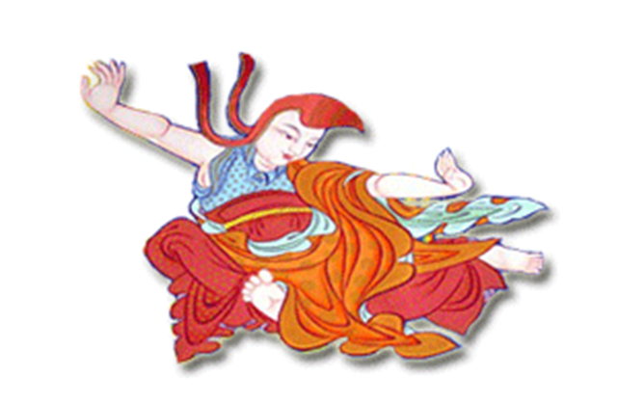
Nub Namkhai Nyingpo was one of the five close-hearted sons and one of the twenty-five principal disciples of Guru Padmasambhava. As an accomplished Yangdag master, he was among the first seven to receive the Gelong (monk) ordination in the eighth century. He received empowerment and pith instructions from both Guru Rinpochhe and Khenchen Bodhisattva, and also the root Lama of the great Dharma King Trisong Detsen.
Namkhai Nyingpo was a revered Bhikshu dedicated to practising fierce yogic discipline in the grand cave of Lhodrak Kharchu. His unwavering devotion led him to achieve Siddhi and receive teachings and empowerment from an Indian master named Humkara. Through his divination skills, he saved King Trisong Detsen from illness, earning respect and admiration. However, his good deeds drew the ire of the Queen and Bon ministers, who exiled him from his homeland.
Despite his exile, Namkhai Nyingpo remained steadfast in his devotion. He had a vision of a Wisdom Dakini, which led him to disguise himself as a mendicant to locate her. During his lifetime, he composed many tunes for various puja incantations, which continue to inspire and move people today. He also performed miraculous feats, including holding the sun still, displaying his attainment beyond physics. Namkhai Nyingpo’s aspirations for the benefit of all beings continue to inspire us today. His journey serves as a reminder that dedication, perseverance, and faith can lead to great achievements, regardless of the challenges.

Namkhai Nyingpo I - Rigzin Lobsang Lhachog
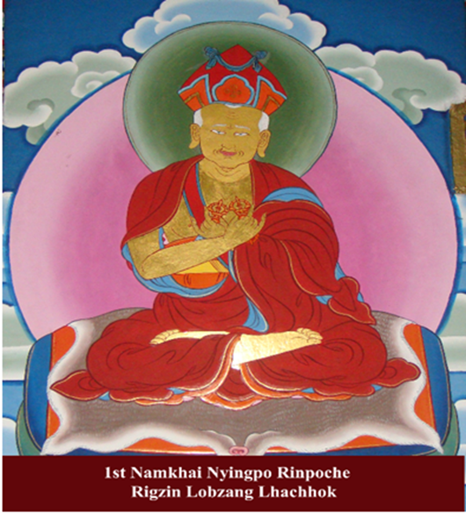
Rigzin Lobzang Lhachog, also known as the First Namkhai Nyingpo, was a prominent figure in the Buddhist community. He was one of the seven Secret Holders of the Three Secrets, which are considered so profoundly that they can only be transmitted orally from a qualified teacher to a disciple deemed worthy. At Lhodrak Kharchu Monastery, he received teachings and was empowered with Kagye – The Eight Pronouncements, a set of teachings designed to help practitioners cultivate wisdom and compassion. He also received complete instruction on Thuje Chenpo’s Khorwa Ingdröl – Liberation from Samsara and beyond, one of the most profound teachings in Buddhism. He meditated in various places, which helped many beings achieve liberation and was known for his deep compassion and ability to help others overcome suffering.
After his peaceful passing, many relics were found after his cremation, a testament to his spiritual attainment. His teachings continue to inspire practitioners around the world to this day.

Namkhai Nyingpo II - Kezang Pema Wangchuk
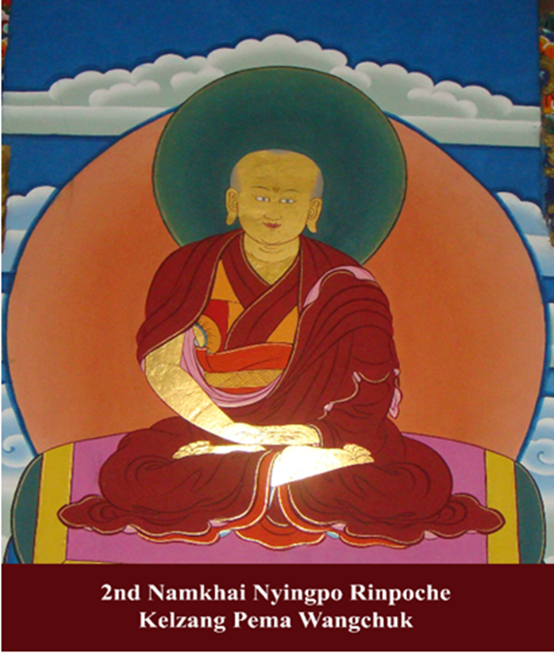
Kezang Pema Wangchuk became the Second Namkhai Nyingpo Rinpoche according to his predecessor’s prophecy. He received teachings from the 5th Dodrak Rigzin and propagated activities of teaching, working, and meditation. Unfortunately, not much is known about his life.
Namkhai Nyingpo III - Jampel Ngawang Drukdra
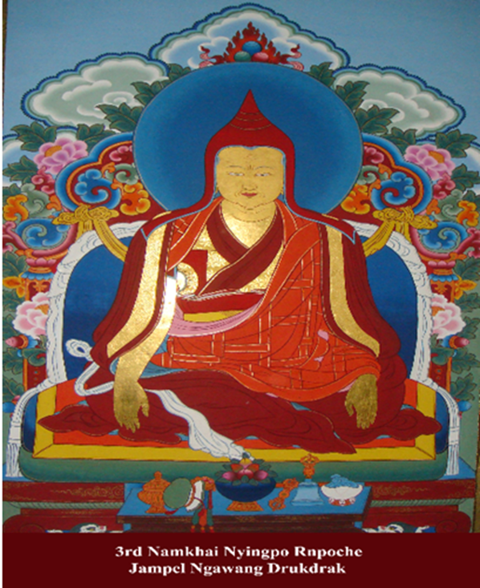
Jampel Ngawang Drukdra was a revered figure, born in a culturally rich region situated between India, Tibet, and Bhutan. He was known to be a visionary leader who worked tirelessly to spread the teachings of Ngagyur. Throughout his life, Jampel Ngawang Drukdra undertook several pilgrimages and visited various parts of India and Bhutan. During one of his journeys, he visited Bhutan where he stayed in the beautiful town of Chhali. While in Chhali, he was approached by a patron who requested the construction of a Bodhi Stupa. Jampel Ngawang Drukdra – being a spiritual leader – saw this as a great opportunity to spread the teachings of Ngagyur. He oversaw the construction of the stupa, which still stands to this day, despite the relics inside being stolen and lost. On his journey to Khengkhar, Jampel Ngawang Drukdra was poisoned by an unknown person in Domangla. However, he managed to leave a footprint on a rock before passing away, which is now kept as a relic in Nyukphu Ódsel Thegchog Monastery. This footprint is a powerful symbol of his spiritual journey and serves as a reminder of the sacrifices that he made to spread the teachings of Ngagyur. Jampel Ngawang Drukdra was truly a remarkable figure who left behind a rich legacy. He was a visionary leader, a wise teacher, and a compassionate human being who touched the lives of many people. His life and teachings continue to inspire people across the globe, and his memory lives on through the Bodhi Stupa and the relics that he left behind.

Namkhai Nyingpo IV - Kunzang Ngawang Tenzin
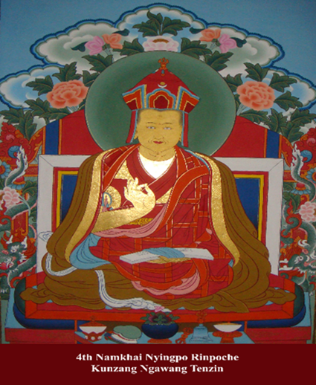
Künzang Ngawang Tenzin was the 4th incarnation of Namkhai Nyingpo, born near Kurje in Bumthang. Under the guidance of Pema Thegchog, he completed his studies, served as an abbot, gave Ripening and Liberation Empowerments, and had numerous disciples. He offered relics and mentored the Royal Emperor of China. He even enslaved the Vajra protector Yamshüd Marpo.
Namkhai Nyingpo V - Kezang Sang-Ngak Thegchog
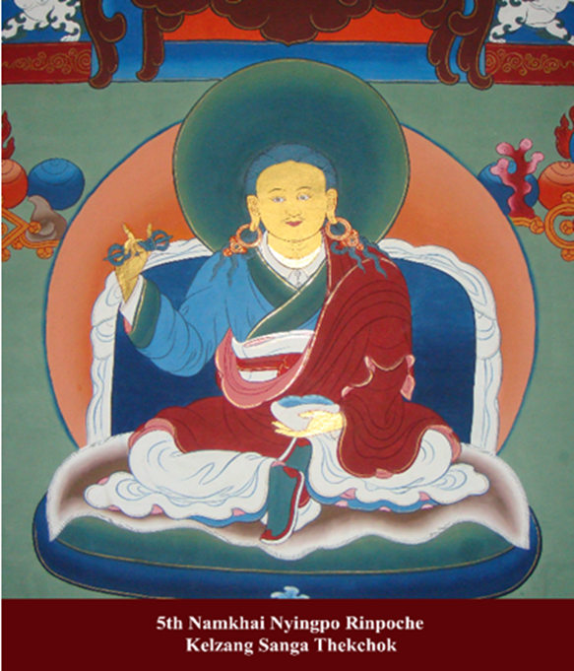
The story of this spiritual leader is truly fascinating. He was born in Lhodrak Dag Med and from a very young age displayed some wondrous signs that pointed towards his unique destiny. As he grew up, he was recognized as a spiritual leader and began to act based on five ideologies without any boundaries. He was known as the “mad lama of Sengre” due to his unconventional approach and his ability to see beyond the material world. One day, while on his way to Shar Benpa, he became ill and handed over a stone to his friend with words of truth and prayers for his successors. This was a significant moment in his life and one where he realized the importance of passing on his knowledge to future generations. At the age of 17, he freed himself from the Eight Worldly Concerns and devoted himself entirely to helping beings reach ripening and perfection. His teachings were simple yet profound and had a profound impact on those who came into contact with him. He was truly a spiritual master who had transcended the limitations of the material world. However, at the young age of 25, he fell ill once again. But this time, he declared that he would return to benefit Buddha’s Dharma and beings. His legacy continues to this day, and his teachings have helped countless people find meaning and purpose in their lives. He will always be remembered as a great spiritual leader who dedicated his life to helping others.
Namkhai Nyingpo VI - Pema Tenzin Thrinley Namgyal Pelzangpo
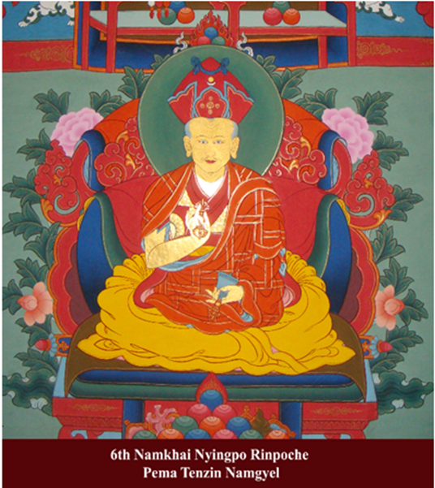
The Sixth reincarnation, Pema Tenzin Thrinley Namgyal Pelzangpo, was born in Lhodrak Zha in 1894. He had memories of his old monastery from childhood and left a footprint on a stone that revealed his identity. He received his ceremonial haircut from scholar Bakha Rigzin Khamsum Yongdrel and was named Pema Tenzin Thrinley Namgyal.
In 1960, while teaching in Bumthang, a teacher showed miraculous powers to monks. He also gave profound teachings during his stay at Sangda Dorji Bechen’s retreat and appointed a principal at Kharchu. He passed away in 1961, and his body was mummified. His disciples gathered to pray and purify their sins. The holy body was cremated in 1981, and a stupa was built to venerate his memory, which can still be seen today at Lhodrak Kharchu monastery.
Namkhai Nyingpo VII - Jamyang Yeshe Tenpai Gyaltshen Pelzangpo
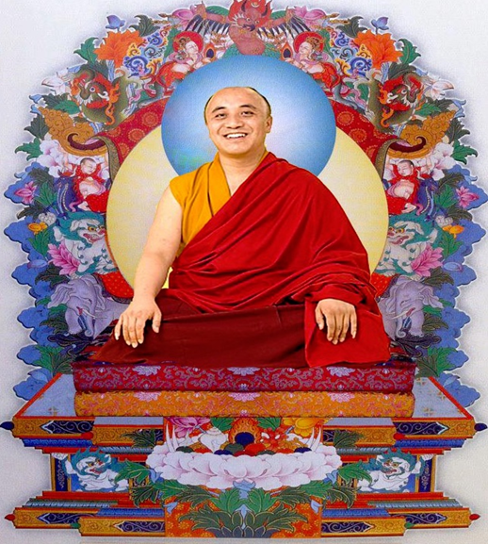
Jamyang Yeshe Tenpai Gyaltshen Pelzangpo is the seventh reincarnation of Namkhai Nyingpo, a prominent figure in the Himalayan region who lived several centuries ago. Jamyang Yeshe Tenpai Gyaltshen Pelzangpo was born in 1966 to Tshering Gyaltshen and Sherab Zangmo in Rinchenphung, a small town located in the eastern part of Bhutan. His predecessor, the 6th Namkhai Nyingpo, predicted his reincarnation during a discussion with Jamba Thokmey, a close associate of Namkhai Nyingpo. According to the prediction, the next incarnation would be born in the same family lineage as Namkhai Nyingpo and would possess certain unique qualities that were present in Namkhai Nyingpo. The signs were valid at the time of Jigme Pema Thrinley’s birth, and he was identified as the seventh incarnation of Namkhai Nyingpo. At Kurje, Bumthang, he was given the name Karma Rigzin Gyurmed Tenpai Gyaltshen Pelzangpo by the 16th Karmapa Rigpe Dorje, who also recognized him as the Trulku. The Karmapa is a spiritual leader of the Karma Kagyu school of Tibetan Buddhism and is highly respected by followers of the religion. Being recognized by the Karmapa is considered a great honour and a sign of spiritual attainment. Kyabje Dilgo Khyentse Rinpoche, another revered spiritual master, entrusted Jamyang Yeshe Tenpai Gyaltshen Pelzangpo with the responsibility of passing on empowerment to future generations. Empowerment is a process through which spiritual energy is transmitted from a master to a disciple and is considered an important aspect of spiritual practice in Tibetan Buddhism. At the age of eight, Jamyang Yeshe Tenpai Gyaltshen Pelzangpo impressed the 16th Karmapa with his reading abilities and received longevity empowerment twice. Longevity empowerment is a special type of empowerment that is believed to enhance the lifespan and health of the recipient. This was yet another sign of Jamyang Yeshe Tenpai Gyaltshen Pelzangpo spiritual prowess and his potential to become a great spiritual master in the future.

Contact Us
- Contact Form: For general inquiries.
- Address: Physical location(s) of the foundation's offices.
- Phone & Email: Direct contact information.
- Social Media Links: Buttons linking to Facebook, Instagram, etc.

VISIT US
THIMPHU, BHUTAN
Druk Tsheringjong,

CALL US
+975 17778892
+975 77778892
+975-2-338892 (Thimphu)
+975-3-631235 (Bumthang)

REACH US
tshokeydorji@gmail.com
www.tshokeydorji.org

Fax: +975-2-337106 (Thimphu)
Fax: +975-3-631401 (Bumthang

